Homework #4
# Due date: 30/Oct, 23:59:59
# Submit a zipped file of your application project folder
# In the application source, you MUST give comments for important lines. Without comments, your solutions will be considered copy&paste codes.
# You also need to provide a screenshot of your result (i.e., Screen of AVD or physical phone).
# Put your answers in “AnswerSheet” section
# You must use Kotlin language.

1) ColorsWap

- You need to create an Android UI with one text field, centered at the top of the screen, and one button.

- The text field will initially display the text “Tap to Change Color”.

- Every time you tap the button, your application needs to generate a random color using RGB values, change the text to that color, and display the values for the color in the following format (assuming you are displaying a light grey with values 100/100/100): COLOR: 100r, 100g, 100b.

- Write a report on how your application works
- Zipped file name should be colorswap.zip

Example)

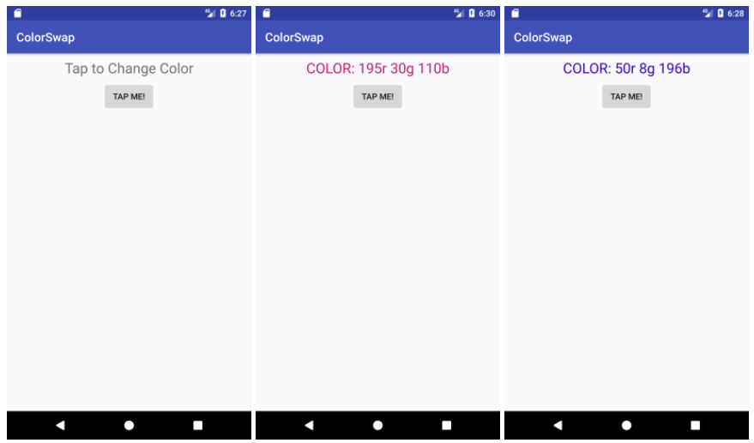
AnswerSheet – Screenshot & Short Analysis on your code
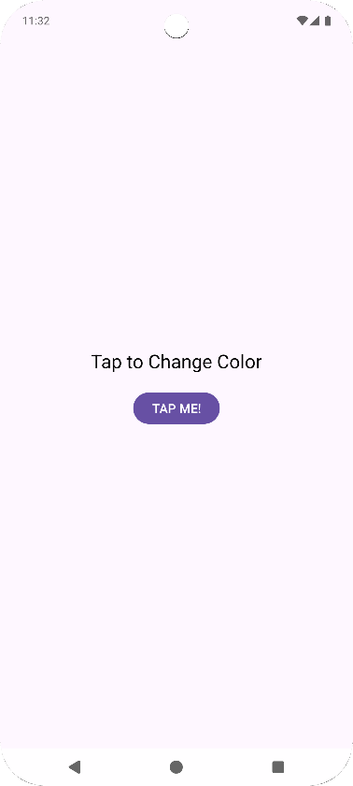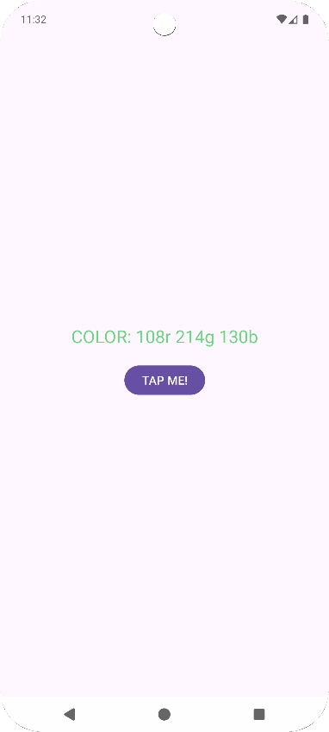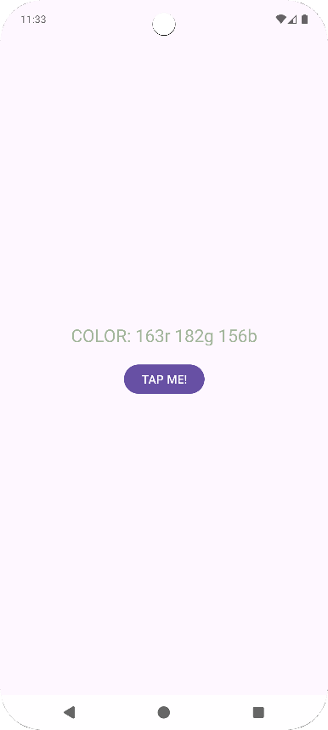
In MainActivity, a TextView and a Button are displayed.
Variables colorText and colorButton are created to hold references to the TextView and Button views.
The colorText view is initialized. Its text is set to "Tap to Change Color" and its text color is set to black.
To ensure the app starts with the same initial screen every time it's launched, colorText.isSaveEnabled is set to false.
A function named setRandomTextColor is defined to execute when colorButton is clicked.
Inside setRandomTextColor:
- Three integer variables, r, g, and b, are assigned random values between 0 and 255, representing the RGB color components.
- Color.rgb(r, g, b) is used to convert these integer values into an actual color.◦The text color of colorText is updated to this new color.
- The text content of colorText is updated to the format: "COLOR: {r}r {g}g {b}b".
Finally, a setOnClickListener is attached to colorButton, which calls the setRandomTextColor function whenever the button is clicked.

2) Your Portfolio

- Create an application to introduce yourself!
- Create your own Application icon
- Include at least 2 activities
- Use at least 1 container component and 1 popup component
- No restrictions on the contents (you can choose your own items/menus)

- Include a short demo video
- Zipped file name should be selfintro.zip

Example)

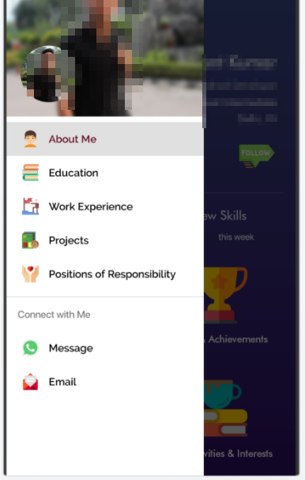

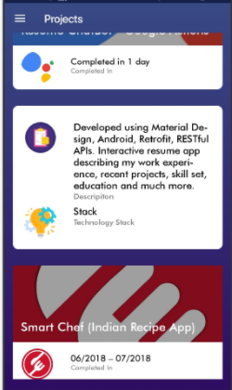

3) Complete the following instructions.
1. Create MainActivity and SubActivity for this assignment.
2. Edit the layout of MainActivity as follows:

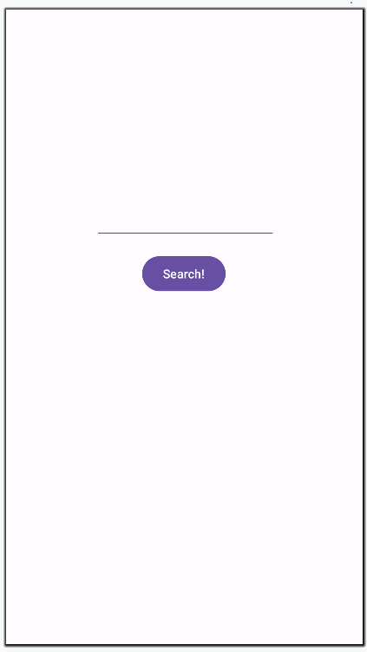

3. Write the code of MainActivity and SubActivity to complete the following scenario:
a) Launch your application. MainActivity must be opened.
b) Type any search keyword in the textedit field.
c) Press “Search” button
d) Your MainActivity must send “implicit intent” to find an application that can handle “web search”, and your application must be shown in the app chooser! (Add an intent-filter to your SubActivity to receive this implicit intent)
e) app-chooser appearance can be slightly different!

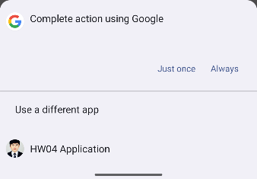

4. If you choose a normal browser application, Chrome application must show the search keyword you provided as well as the web search result.



5) Press back button to go back to your application
6) Press Search button again in the MainActivity
7) In an app chooser dialog, if you choose your own application (e.g., HW04Application), your SubActivity must handle this request:
a) Take the search keyword included in the intent
b) Display the search keyword on the top
c) Take some messages from the user using a multiline text view
d) Once completed, press Return button

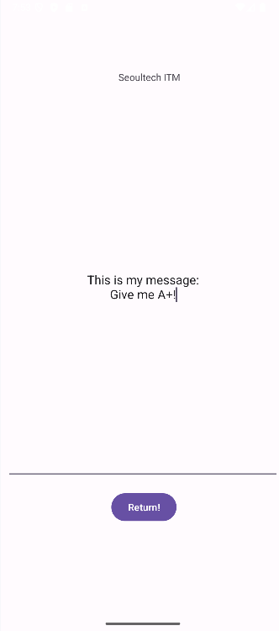
8) MainActivity must display the text from the subactivity using Snackbar dialog!
- For the use of Snackbar, lazy initialization of a binding variable can be required as below:
class MainActivity : AppCompatActivity() {
val binding by lazy { ActivityMainBinding.inflate(layoutInflater) }
…
override fun onCreate(savedInstanceState: Bundle?) {
super.onCreate(savedInstanceState)
…
}
…
}

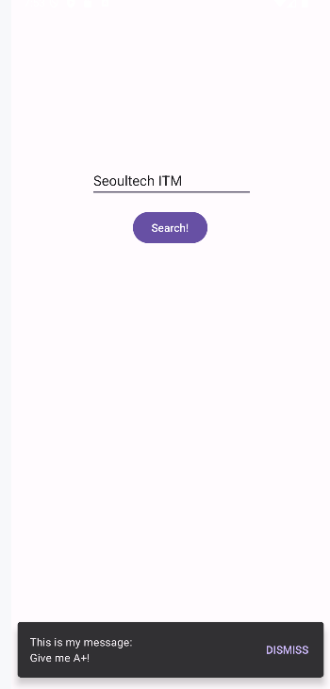

For this question, you have two options
1) Use startActivityForResult() APIs (deprecated ones)
2) Use Activity Result APIs (new recommendations)

Try to use Activity Result APIs first.
If you fail to use them, then use old APIs (startActivityForResult)
Refer to the video example for better understanding.
- Zipped file name should be intent-ex.zip

AnswerSheet – Logic description (Explain how your application works, briefly)
Overall Structure
- MainActivity: Handles search term input and the Search button.
- SubActivity: An internal activity within the app that directly processes the web search request and returns user input results to the MainActivity.

MainActivity
- When the user enters a search term and presses the Search button, an ACTION_WEB_SEARCH intent is created.
- This intent is an implicit intent, which sends the request to any app capable of performing a web search.

val intent = Intent(Intent.ACTION_WEB_SEARCH).apply {
putExtra(SearchManager.QUERY, query)
}

- A Chooser is then displayed, showing a list of apps that can handle the web search intent.
- In the test environment, Google and intent-ex (this app) appear in the list.
- intent-ex appears because it is registered in the Manifest to handle the same intent action.
- If the user selects Google, the app performs a standard web search using the entered query.
- If the search field is empty, a Toast message appears at the bottom of the screen prompting the user to enter a search term.
- If the user selects intent-ex, the SubActivity is launched, transitioning the screen from MainActivity to SubActivity.
- The result returned from SubActivity is received via the Activity Result API callback.
- The received message is then displayed as a Snackbar at the bottom of the screen.

SubActivity
- Receives the query entered in MainActivity and displays it at the top of the screen.
- The user can type a message in the multi-line input field and press the Return button.
- When pressed, the app switches back to MainActivity and returns the entered message as a result.
- If the message field is empty when Return is pressed, the Snackbar is skipped.
- SubActivity is registered in the Manifest to handle web search intents
AnswerSheet – Screenshot

